VoIP Lab Part 2

# CCNP Lab 8

## Axel Li

## 5 April 2019

# Purpose

The purpose of the lab was to configure a Voice over IP network with additional. Our task was to configure voicemail, music on hold, custom ringtones, and dial-out features on two phones, and be able to demonstrate that those features were working as intended.

# Background

Voice over IP is a technology which transmits voice data using IP packets rather than a traditional phone line. This means phones can be used on a LAN without needing to purchase phone lines for a phone network, providing an alternative to PTSN which requires a dedicated network of phone lines. This allows for lower costs from not needing traditional copper wire phone systems in addition to simpler management. VoIP also can combine different forms of communication, such as telephones, voice and video conferencing, and email, into a single system that can be used by computers, phones, and mobile phones. In addition, VoIP allows for useful add-ons such as dial-out and voicemail as well as customizable add-ons such as custom ringtones and music on hold.

VoIP implements a best-effort system without QoS, and typically handles data first-come first-serve with packets sent sequentially. Thus, VoIP may suffer from data loss, latency, and jitter, especially in networks with high traffic. Despite these drawbacks, VoIP has become more popular in use in corporate and consumer settings due to the number of benefits it provides in cost, use, and management.

# Summary

My partner and I set up a basic configuration similar to that of the last lab. In addition to CUCM, we installed a CUC server on another virtual machine, which was necessary for implementing voicemail. To dial out, we attached our router to a PSTN device allowing us to access outside lines. For the custom ringtone and music on hold, we used TFTP to send music files in .wav formats to the servers. We also had to edit the Ringtone.xml file via TFTP to put the custom ringtones to the phones. After finishing all the components of the lab, we then tested each aspect to ensure that they were working correctly.

# Commands

The key commands used in this lab for the router were:

voice-port [interface] – voice interface to configure

connection plar opx [directory number] – specifies the number reachable from the outside

ccm-manager config server [ip address] – specifies the CUCM server

mgcp call-agent [ip address] service-type mgcp version 0.1 – same as above

dial-peer voice 10 voip – allows dial-in from the outside

destination-pattern 1111 – specifies the destination directory number

session target ipv4:[ip address] – directs the call to a specific IP

dial-peer voice 1 pots – allows dial-out

port [interface] – specifies the egress interface

# Tables and Diagrams

Topology:

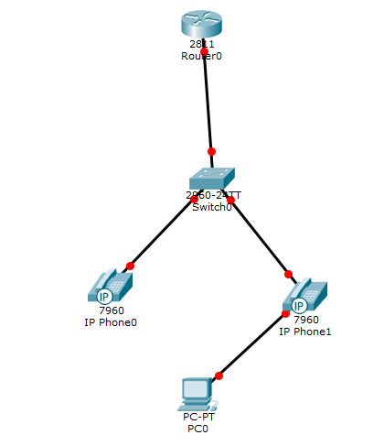

Note that the PTSN device is not included in the topology; it is directly connected to the router.

# Configurations

Router Configuration:

hostname R1

no aaa new-model

resource policy

memory-size iomem 10

no network-clock-participate slot 1

ip subnet-zero

ip cef

no ip dhcp use vrf connected

ip dhcp pool Voice

  network 192.168.0.0 255.255.255.0

  default-router 192.168.0.1

  option 150 ip 192.168.0.2

ip dhcp pool Data

  network 192.168.0.16 255.255.255.240

  default-router 192.168.0.17

  option 150 ip 192.168.0.2

voice call send-alert

voice rtp send-recv

voice service voip

h323

interface FastEthernet0/1.1

encapsulation dot1Q 10

ip address 192.168.0.1 255.255.255.240

no snmp trap link-status

interface FastEthernet0/1.2

encapsulation dot1Q 20

ip address 192.168.0.17 255.255.255.240

no snmp trap link-status

voice-port 0/3/1

signal groundStart

timing hookflash-out 50

timing guard-out 1000

connection plar opx 1111

caller-id enable

ccm-manager config server 192.168.0.20

ccm-manager config

mgcp call-agent 192.168.0.20 service-type mgcp version 0.1

mgcp profile default

dial-peer voice 10 voip

destination-pattern 1111

session target ipv4:192.168.0.20

dtmf-relay h245-signal h245-alphanumeric

dial-peer voice 1 pots

destination-pattern 9T

direct-inward-dial

port 0/3/1

forward-digits 11

telephony-service

max-ephones 2

max-dn 2

ip source-address 192.168.0.20 port 2001

create cnf-files version-stamp 7960 Jan 22 2015 23:53:36

max-conferences 8 gain -6

transfer-system full-consult

scheduler allocate 20000 1000

ntp master

Switch Configuration:

en

config t

hostname S1

vlan 10

name Voice

vlan 20

name Data

int range fa0/3 - 4

switchport mode access

switchport voice vlan 10

switchport mode access

switchport access vlan 20

int fa0/20

switchport trunk encapsulation dot1q

switchport mode trunk

Music on Hold:

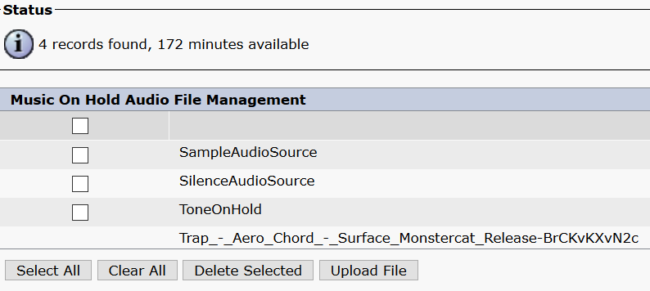

Upload the music file desired with the respective button.

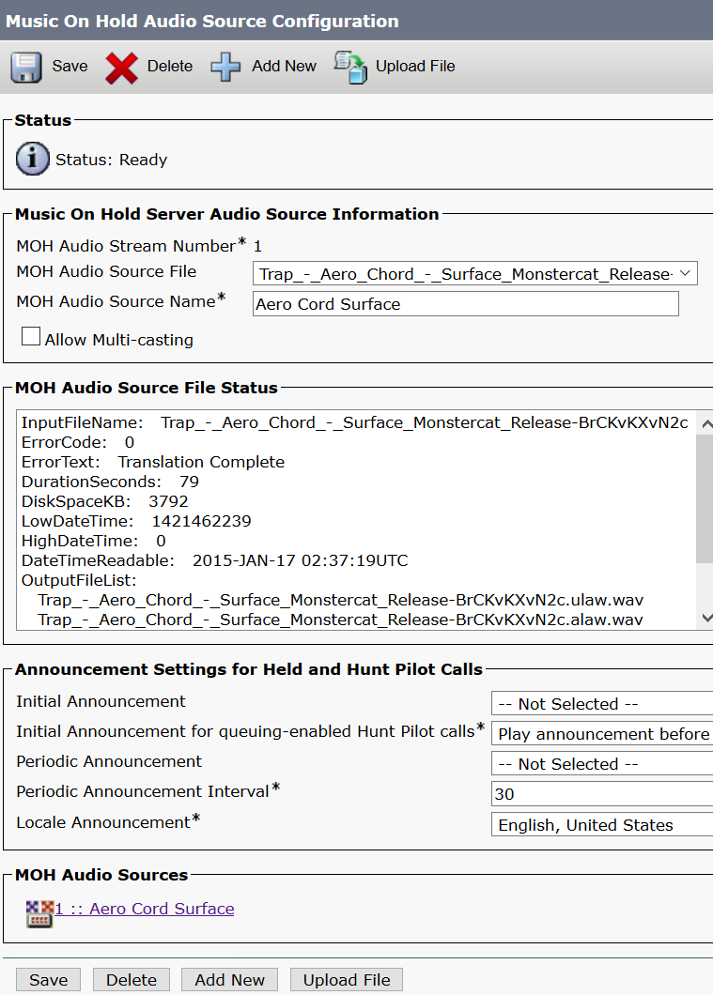

An Audio Source Configuration needs to be set up for updating the phones with music. The “MOH Audio Source File” should be the music file previously uploaded.

Custom Ringtone:

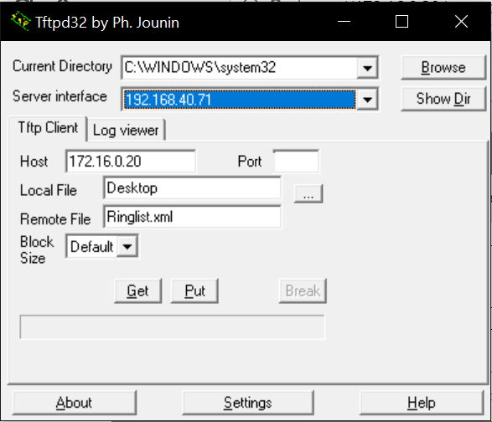

Use TFTP32 to obtain Ringlist.xml from the CUCM server.

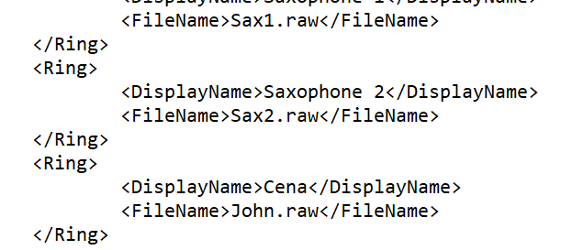

Add another entry to the list of ringtones. The filename must be exactly that of the file, but the display name can be any name.

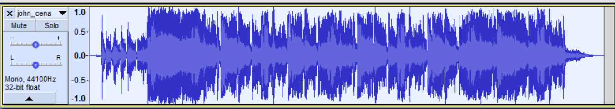

Select a ringtone and open it in an digital audio editor. Change the ringtone to mono, set the frequency to 800 Hz, and shorten the clip to a few seconds.

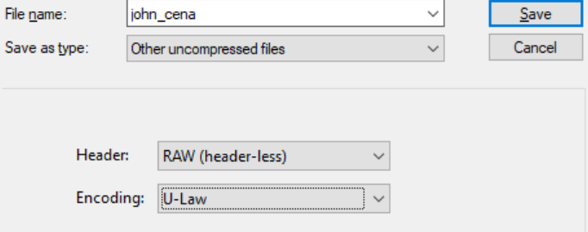

The ringtone will need to be saved as “Other uncompressed files”, “RAW” header, and “U-Law” encoding for CUCM to properly read the file.

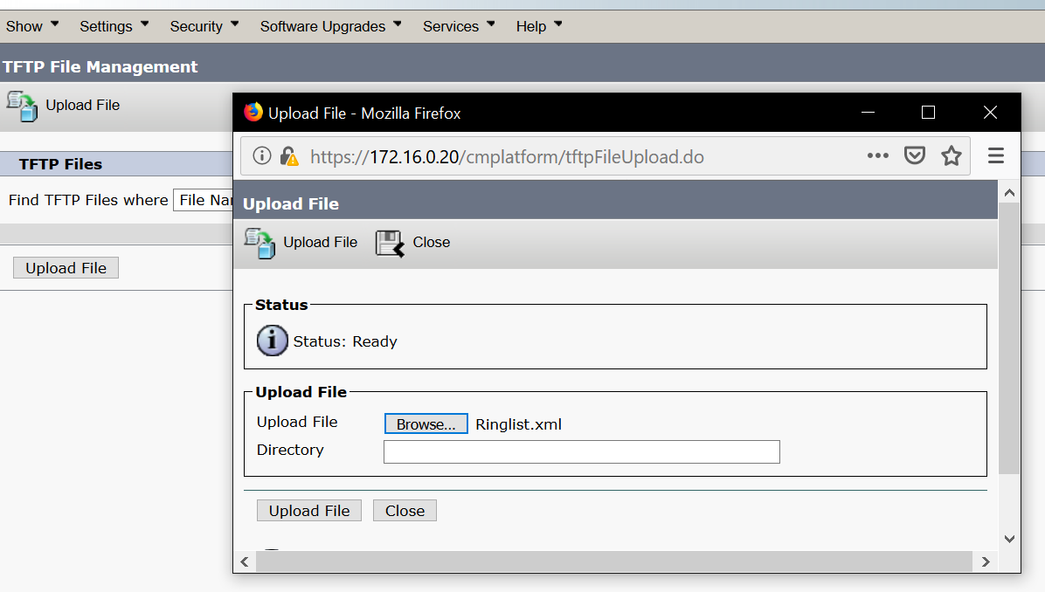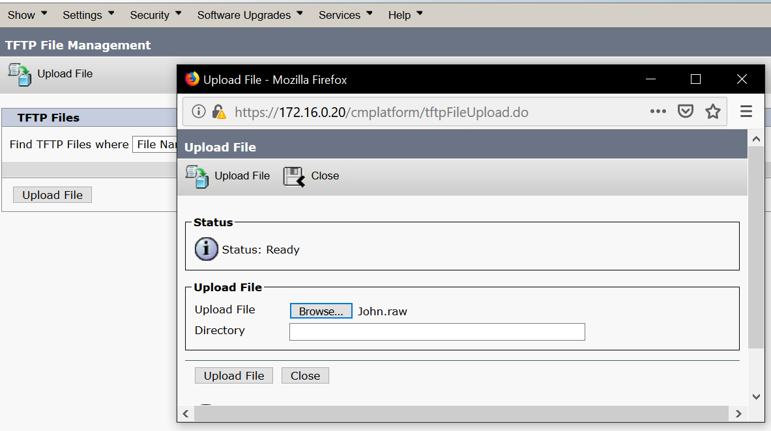

Upload Ringlist.xml and the edited ringtone to the “TFTP File Management” page, which is under CUCM serviceability.

Voicemail (CUC):

The following steps are to be done in the CUC server. All configurations should match that of the CUCM server.

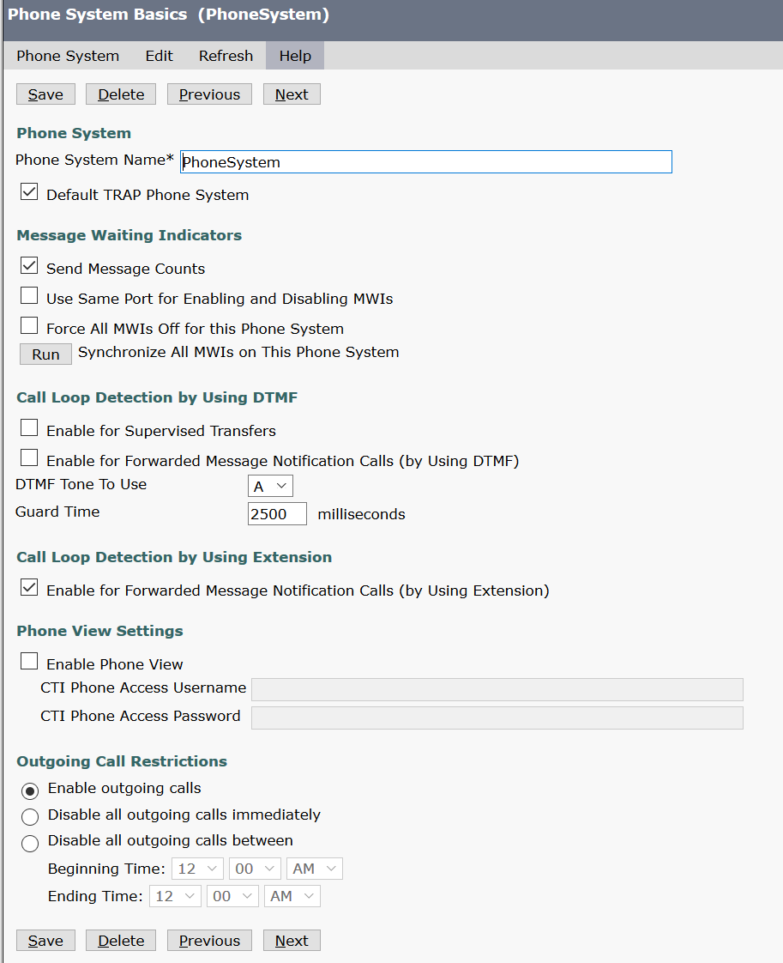

Create a new phone system and specify the necessary information.  
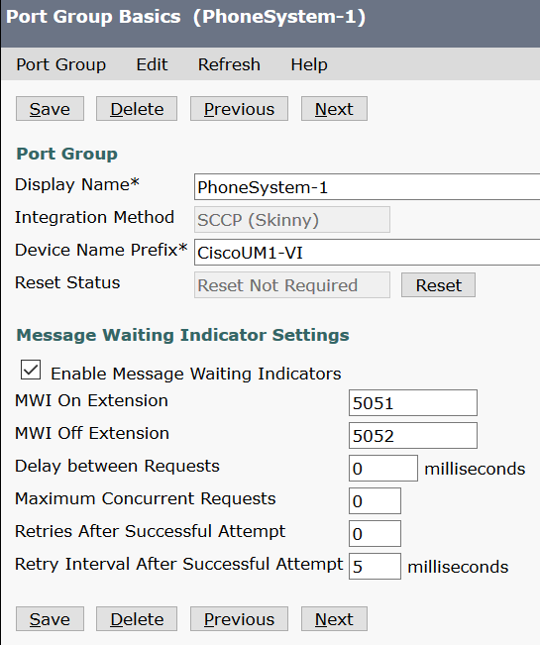

Also configure a port group. The numbers for MWI On and Off will be used by users to access the voicemail options.

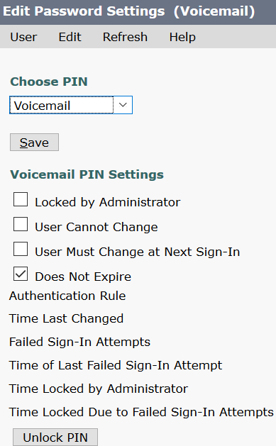

Create a user profile for each phone.

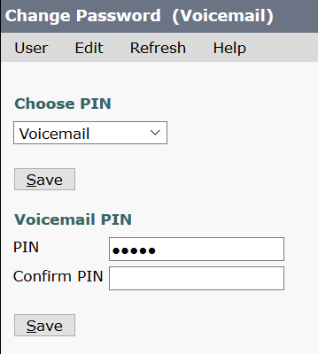

Select a PIN used to access the voicemail inbox.

Voicemail (CUCM):

The configuration should mirror that of the CUC voicemail configurations.

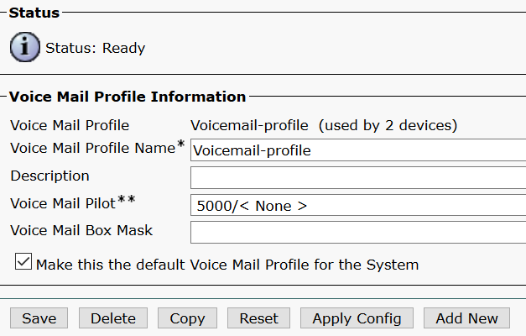

Fill out the necessary information here.

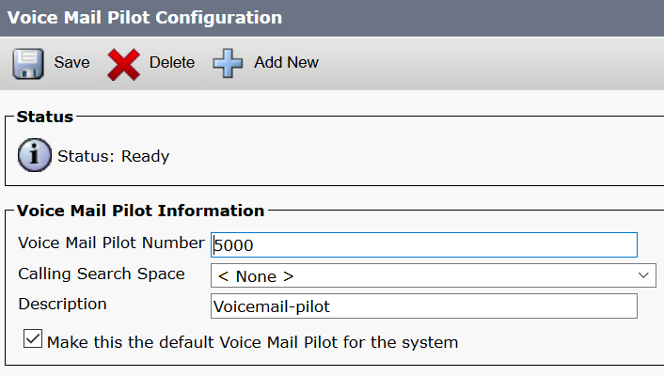

The “Voice Mail Pilot Number” specifies the number users dial to access their voicemail.

Dial In and Dial Out:

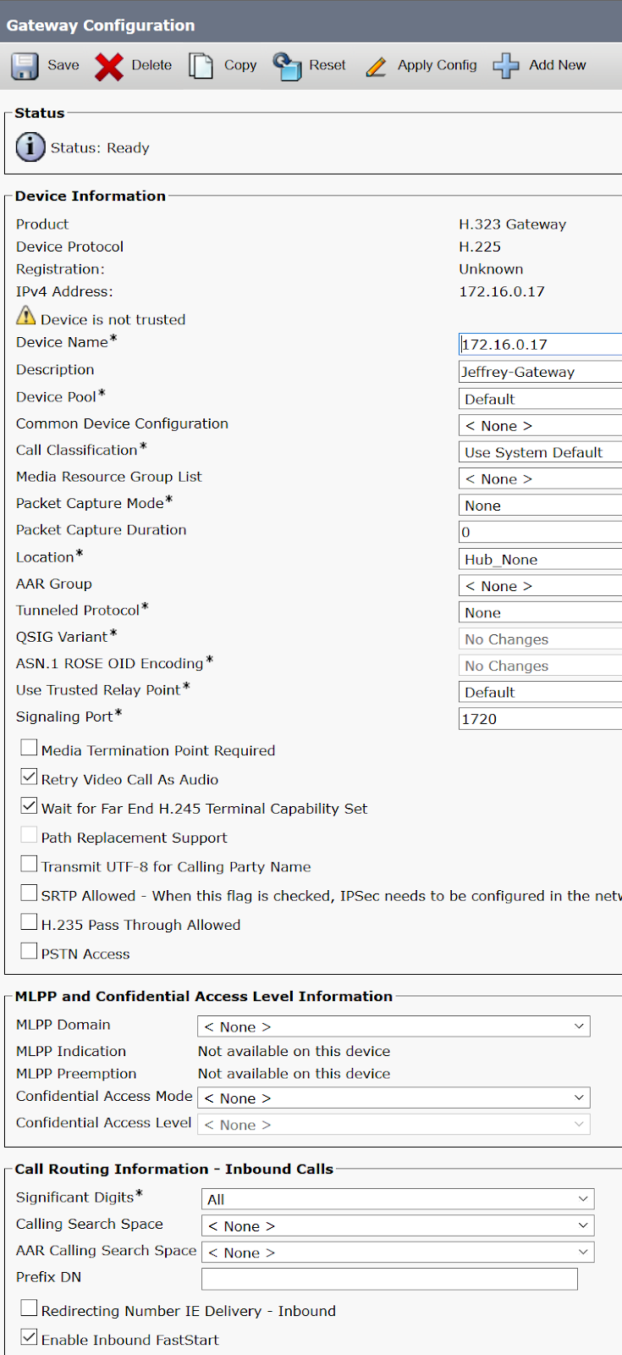

Create a h.323 gateway with device name set to the router IP address. Select the “Enable Inbound Fast option.

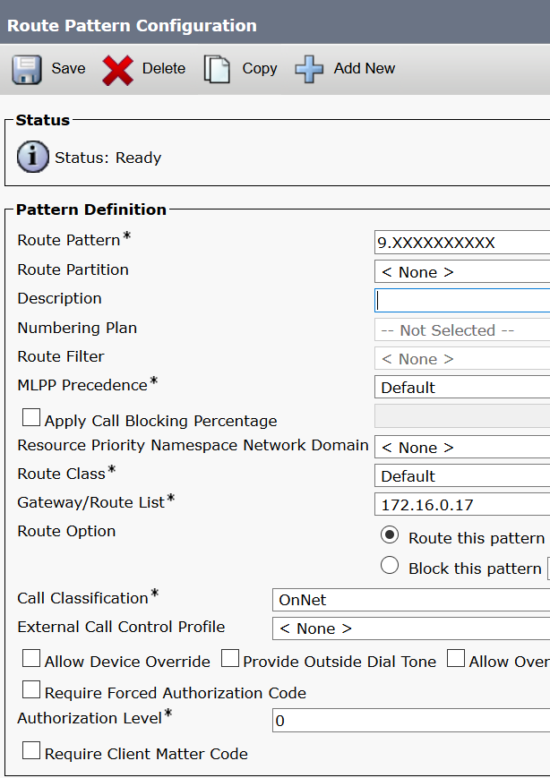

Create a route pattern and fill out the necessary information.

# Problems

We experienced a multitude of problems throughout this lab. Voicemail was particularly difficult as there were many moving components and involved configuration on both CUCM and CUC. When starting out, we did not realize that we needed to use a specific router with a FXO port for dialing in and out initially, which we realized when some of the commands failed to work. We also ran into troubles with dial-in and dial-out due to the PSTN device simply not working, which was especially frustrating.

# Conclusion

This lab was a particularly difficult exercise in implementing various VoIP features. It was challenging figuring out what we needed to do specifically at the start, and we ran into many confusing issues along the way due to having no prior knowledge of VoIP. In the end, we gained valuable knowledge and experience with setting up more advanced features of a VoIP system.